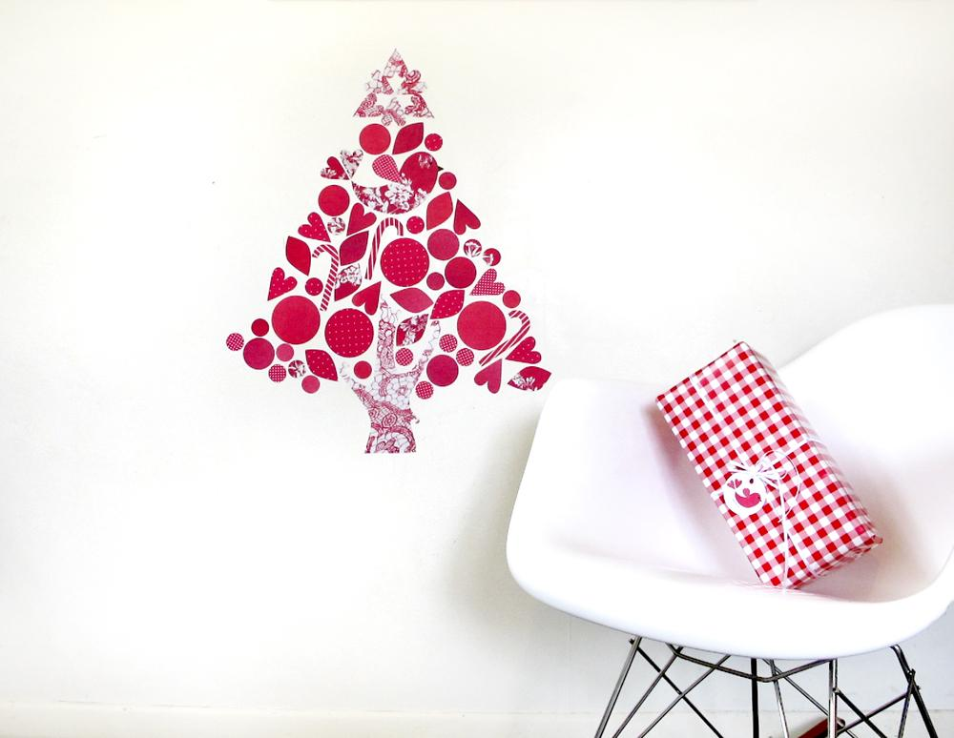
CHRISTMAS PRE-ORDER
discount form 2014
Thanks for shopping with tinch this Christmas!
Pre-ordering ensures your custom pressies will be made and shipped (anywhere in the world) in time for Christmas. And you get 15% discount & free shipping for forward-thinking!

How this works:
- Fill out this pre-order form and return it to Helen@tinch.co.nz by Friday October 31, 2014.
- I’ll confirm your order by sending an invoice, including 15% discount & free shipping.
- You have until until Friday November 7, 2014 to pay by your chosen method.
- Your order will be shipped to you, or your chosen recipient(s) by November 28 - guaranteed to arrive anywhere in the world by Christmas!

Name
Email address
Postal address
Include Postcode & Country
Preferred Payment method  (Choose one) | - NZ bank deposit  - Credit card via PayPal
Gift wrapping required?
We can wrap & send direct to recipients for you. Type any instructions, messages & addresses here
Any other requests/notes? I’ll reply with info/quotes as needed

MAGNETIC WALLSCAPES >> view online here <<
ITEM NAME  >> see items online here << | price | less 15% | custom colours / patterns / notes  (If left blank - you’ll get a surprise!) | quantity | subtotal
Fantail (single) | 29.00 | 24.65 | N/A - vintage wallpapers & fabrics
Fantail & Pohutukawa branch | 39.00 | 33.15 | N/A - vintage wallpapers & fabrics
Kereru & Kowhai branch | 45.00 | 38.25 | N/A - vintage wallpapers & fabrics
Lovebird (single) | 16.00 | 13.60
Lovebirds & branch | 39.00 | 33.15
Baby owl (single) | 12.00 | 10.20
Owl (single) | 16.00 | 13.60
Owls & branch | 39.00 | 33.15
Swallow (single) | 12.00 | 10.20
Swallow Pair | 20.00 | 17.00
Heart Pair (set of 2, approx 75mm) | 9.00 | 7.65
Lucky dip hearts  (mixture of 10, 45-55mm) | 10.00 | 8.50 | N/A - random assortment of colours & sizes
Lovehearts  (set of 6, approx 75mm) | 20.00 | 17.00
Family Tree | 129.00 | 109.65
Tree Community  (tree + birds + +owl + cloud + ladybugs) | 169.00 | 143.65
Rainbow  Choose from: BRIGHT or PASTEL | 39.00 | 33.15
Set of 7 Fish (approx 85mm) | 16.00 | 13.60 | Colours of the rainbow
Sailboat Set | 39.00 | 33.15
Nautical Sunday  (lighthouse + boats complete wallscape) | 169.00 | 143.65
Mini bunting flags  (set of 7, 65mm, for fridge) | 16.00 | 13.60
Picture Frame 6x4” (single) | 20.00 | 17.00
Picture Frame 6x4” (set of 3) | 55.00 | 46.75
A4 Picture Frame (single) | 39.00 | 33.15
Geoscape (15 pieces) | 39.00 | 33.15 | Any 3 colours:
Building Blocks | 99.00 | 84.15
Train Carriage (each)  Choose carriages: engine, cargo, passenger, container, tanker, caboose | 25.00 | 21.25
Letter magnet (ea)- spell anything | 4.00 | 3.40
Alphabet Soup | 79.00 | 67.15 | N/A - Random variety of bright materials
Number Stew | 34.00 | 28.90 | N/A - Random variety of bright materials
Custom name (Up to 5 letters, add letters below)  >> See examples here << | 45.00 | 38.25 | NAME:  CHARACTER (bird, owl etc):  EXTRAS (leaves or hearts):  COLOURS:
Extra letters for custom name set  ($3 each) | 3.00 | 2.55
Quote/unquote magnets  Choose ROUND or SQUARE | 16.00 | 13.60
Fridge Clock - dots design | 89.00 | 75.65
Fridge Clock - 1-12 numbers | 89.00 | 75.65
Fridge Clock - huge numbers | 89.00 | 75.65
Giant Fruit magnet  Choose WATERMELON or PINEAPPLE | 25.00 | 21.25
Feather magnets  (set of 6, approx 17cm each) | 29.00 | 24.65
Christmassy magnetic wallscape | 79.00 | 67.15

OTHER PRODUCTS
ITEM NAME | price | less 15% | notes | quantity | subtotal
Cracker kitset (per cracker)  state how many crackers you need  Heart STICKERS or MAGNETS? | 4.50 | 3.85
Heart magnet Tree Decorations  2x 55mm hearts on ribbon | 4.50 | 3.85
Christmassy Gift Tags (6 pack) | 5.00 | 4.25 | N/A
Christmas Cards & tags (3 each) | 16.00 | 13.60 | N/A
Colouring booklet – 28 pages | 20.00 | 17.00 | N/A

RESTICKABLE WALLSCAPES >> view online here <<
Item name  >> see items online here << | price | less 15% | Colour choice / notes  Only items marked * are customisable & handmade. The rest of the restickable range is printed in set colours, as stated. | quantity | subtotal
Single birdie - choose from:  Pink/red  Black & multi colour spots  Yellow/pink | 16.00 | 13.60
Lovebirds & branch - choose:  Pink florals  Orange/black spots | 44.00 | 37.40
Single owl - choose from:  Orange  Purple  Green  Teal  Blue  Red | 9.00 | 7.65
Owl friends - set of 6 | 30.00 | 25.50 | N/A
Family Tree | 129.00 | 109.65 | N/A
Tree Community | 169.00 | 143.65 | N/A
Rainclouds | 30.00 | 25.50 | N/A
Rainbow | 29.00 | 24.65 | N/A
Owl in a Balloon | 30.00 | 25.50 | N/A
Up, Up & Away | 89.00 | 75.65 | N/A
Dress-Up Kid - choose from:  Bold & Girly  Soft & Girly  Monotone  Blue & Green  Bright & Bold | 16.00 | 13.60
Drawer Organisers - choose:  Bold & Girly  Soft & Girly  Monotone  Blue & Green  Bright & Bold | 39.00 | 33.15
Restickable Wall Ruler  - choose from:  Grey  Yellow  White  Also choose flag colour:  Grey  Yellow  White | 89.00 | 75.65 | RULER COLOUR:  FLAG COLOUR:
Extra Flags for Wall ruler  Grey  Yellow  White | 9.00 | 7.65
Restickable EveryDates ie. JAN 01  - choose from:  White text on black  Black text on white | 89.00 | 75.65
Restickable EveryDays MON-SUN  - choose from:  White text on black  Black text on white | 49.00 | 41.65
Christmassy Wallscape | 69.00 | 58.65 | N/A
Lucky dip hearts *  (mixture of 10, 45-55mm) | 10.00 | 8.50 | N/A - random assortment of colours & sizes
Restickable mini bunting flags*  - choose from:  Red & white  Grey & yellow  Orange  Teal Green  Navy Blue  Soft Blue  Soft Pink  Monochrome black/white/grey  Or type your own colour choices | 16.00 | 13.60
Custom name* (Up to 5 letters, add letters below)  >> See examples here << | 45.00 | 38.25 | NAME:  CHARACTER (bird, owl etc):  EXTRAS (leaves or hearts):  COLOURS:
Extra letters for custom name set  ($3 each) | 3.00 | 2.55
Restickable wall Clock - dots design * | 89.00 | 75.65
Restickable wall Clock - 1-12 numbers * | 89.00 | 75.65
Restickable wall Clock - huge numbers * | 89.00 | 75.65
Unicorn & wreath* | 30.00 | 25.50
Photo Sticker Uppers 10 pack* - choose from:  Hearts  Raindrops  Dots  Triangles  Type colour/pattern choices | 16.00 | 13.60 | SHAPE:  COLOUR:
 |  |  |  | TOTAL

